

***Chorley Parish Church of St. Laurence***

***in the Church of England Diocese of Blackburn***

**Health and Safety Policy**

**Issue 6.0 July 2024**

**1. Introduction**

The PCC is committed, so far as is reasonably practicable, to providing a safe and healthy environment and conditions for its staff and volunteers, church members, all involved in its activities and all who use its premises. This policy outlines how this can be achieved and incorporates the requirements of the:

* Health and Safety at Work Act 1974 (and the regulations made under it.)
* Management of Health and Safety at Work Regulations 1999
* Regulatory Reform (Fire Safety) Order 2005
* Food Safety Act 1990, and EU food hygiene law (as interpreted by the Food Standards Agency).

However, the policy goes beyond statutory requirements in some areas, as a matter of good practice and care for all people involved in church life (e.g., provision of basic first-aid provision during church activities.)

The policy will of course be most effective if all church staff and volunteers, other church members, and those who participate in church activities or use its premises, do the following:

* Take reasonable care for their own health and safety and that of others who may be affected by what they do or do not do.
* Cooperate with the church on health and safety.
* Correctly use work items provided by the church (including personal protective equipment) in accordance with training and instructions.
* Not interfere with or misuse anything provided for health, safety, or welfare.

This policy and procedures should be interpreted in the light of detailed advice and guidance from sources such as:

* Ecclesiastical Insurance Church health and safety policy with guidance notes, <https://www.ecclesiastical.com/churchmatters/churchguidance/churchhealthandsafety/index.aspx>
* Health & Safety Executive, <http://www.hse.gov.uk>

**2. Scope**

This policy covers all Clergy, staff, voluntary workers, contractors, organisations/individuals hiring and/or anyone visiting the church premises.

**3. Roles and responsibilities**

|  |  |
| --- | --- |
| **Overall and final responsibility for health and safety is that of:** | *Chorley Parish Church of St Laurence Parochial Church Council* |
| **Day-to-day responsibility for ensuring this policy is put into practice is delegated to:** | *Health and Safety Team* |

**4. To prevent accidents and cases of work-related ill health and provide adequate control of health and safety risks arising from church activities.**

**Name of responsible person(s):** *Health & Safety Team*

*Churchwardens*

**Risk assessments**

* Risk assessments will be completed for the church premises and church activities. Actions arising out of those assessments will be implemented. Risk assessments will be reviewed at least every year, or sooner if changes are made to church premises or church activities. Copies of these assessments will need to be submitted to the church office prior to commencement of any of the below-mentioned events taking place.

They will include:

* A general risk assessment completed by the church health & safety team (attached as Appendix 1)
* Specific risk assessments completed by employees and volunteers for the groups / activities and events which they organise. These risk assessments will take account of children’s changing needs as they grow and develop and will be mindful of needs resulting from physical and learning disabilities and factors that may make some children and adults more vulnerable than others.
* Specific risk assessments completed for each off-site activity. If transport is organised by the church, then the risk assessment will include travel arrangements and measures will be taken to ensure qualified and safe drivers; roadworthy vehicles' suitable insurance cover; and use of seat belts or appropriate car seats.

Group / activity leaders should carry out a quick visual inspection of the area being used for their meeting / event / activity before starting, note any concerns, take whatever immediate action is possible to reduce the risk of harm, and report any concerns to the Health & Safety Team as soon as possible after the event.

**Electrical issues**

Misuse and abuse of electricity is a significant cause of fires and injury. Faulty electrical equipment can kill. All employees and voluntary workers must observe the following:

* Visually check all electrical equipment before use.
* Report all faults immediately to the responsible person.
* Do not attempt to use or repair faulty equipment.
* Electrical equipment should be switched off and disconnected when not in use for long periods.
* Electrical equipment which is brought onto the premises and used should be tested by the approved person and entered in the electrical equipment record.
* Flexible cables should be positioned and protected so that they do not constitute a tripping hazard and are not subject to mechanical damage.

**Manual handling**

We will eliminate the need for manual handling as far as is reasonably practicable. Where it is not possible to avoid the need to move loads, we will carry out risk assessments and make use of lifting aids, including trolleys, lifts and hoists as far as possible. The necessary training will be given to all employees and volunteers who are required to undertake manual handling as part of their church work. When carrying out manual handling assessment the following procedure will be utilised:

1. The job or task is defined.
2. The workplace is noted.
3. The assessment team is recorded. This must include a team leader who will usually be a responsible manager who has had formal training in undertaking assessments. It is much preferred if the people who are to be tasked with the job are also included as this will develop awareness and understanding of the safety management system.
4. The date that the assessment is being undertaken is to be recorded.
5. The team considers if the task poses a significant risk of injury if it can be avoided or mechanised and is the task within the guidelines in Schedule 1 of the Manual Handling Operations Regulations 1992. This will define whether to simply carry out an assessment or to consider the task in detail then carry out the assessment.
6. When considering the task in detail; the assessment teams consider several aspects of the task, the load, the environment, and individual capability. The risk posed by each consideration is determined as either low, medium, or high.
7. When carrying out the manual handling assessment, if a task assessment has been undertaken the high-risk aspects should be addressed first then medium and finally low.
8. At the manual handling assessment, the overall risk of injury is assessed.
9. The weights involved in the task are recorded.
10. The actions or controls required to reduce the risk to a low or insignificant level are listed and these are to be signed off when implemented which must be prior to the task being performed.

**Display Screen Equipment (DSE) Assessing and Monitoring**

The prolonged or inappropriate use of DSE can attribute to work related upper limb disorders (WRULD) or repetitive strain injury (RSI). We will protect our employees who use such equipment for a significant part of their work from these effects as far as we reasonably can. We will do this by the following means:

Within one month of starting work with us, an assessment will be carried out with them to ensure that the workstation is acceptable and suitable for their needs. The assessment is to include a demonstration of the adjustments the worker is empowered to make to their workstation and includes the following:

1. How to adjust the chair. Including height, base, back and arms.
2. How to adjust the keyboard.
3. How to adjust the monitor. Including height, swivel, contrast, brightness and colour.
4. Issue the guidance regarding DSE use as in the appendices.

We will re-assess the worker and workstation in the event of changes in the individual capability or where there has been some significant change to the workstation or office design or layout.

**Contractors**

Anyone entering church premises for the purposes of carrying out work, other than an employee or voluntary worker of the church, will be regarded as a contractor.

All contractors, including the self-employed, must abide by the following:

* Provide a copy of their own health and safety policy (where required by law) before starting work.
* Provide evidence that they have appropriate Public and Employers’ Liability insurance in place before starting work.
* Where plant and machinery is brought onto the church premises by contractors, they must be able to show where necessary that the equipment has been inspected and tested to ensure its safe operation before starting work
* Contractors may only use sub-contractors or persons other than their own direct employees with permission from the church. However, responsibility will remain with the contractors.
* All contractors will be given instructions regarding the areas where they are permitted to work, the extent of the work they are authorised to undertake, and any safety precautions they must take.

**5. To provide adequate information and training to ensure employees and volunteers are competent to do their work**

**Name of responsible person(s):** *Health & Safety Team*

*Churchwardens*

Staff and volunteers will be given necessary health and safety induction and provided with appropriate training.

Other building users (e.g., organisations letting the church premises) will be given necessary health & safety information, including a copy of this policy and a risk assessment for the premises. Staff and volunteers must provide risk assessments for their activities which are not covered under the general risk assessment policy for use of the church facilities.

**6. To engage and consult with employees and volunteers on day-to-day health and safety conditions and provide advice and supervision on occupational health**

**Name of responsible person(s):** *Health & Safety Officers*

*Churchwardens*

Staff and volunteers will be routinely consulted on health and safety matters as they arise and formally consulted for annual health and safety review meetings (or sooner if required.)

**7. To implement emergency procedures - evacuation in case of fire or other significant incident - to fulfil the obligations under the Regulatory Reform (Fire Safety) Order 2005.**

**Name of responsible person(s):** *Health & Safety Team*

*Churchwardens*

Fire risk assessment reviewed annually (either separately or as part of the annual health & safety review).[1]

Fire detection, warning and evacuation procedures are tested regularly and updated as necessary.

Fire drills will be held regularly for the whole church and particular groups, especially for groups involving children or people with a disability. Evacuation procedures are attached in appendix 2.

Fire/Emergency exits are clearly identified with the appropriate signage and emergency lighting systems installed where required.

Fire alarms, smoke detectors and fire fighting equipment (e.g. fire extinguishers) are in place. The fire alarm is regularly tested every Thursday evening and properly maintained by a competent technician or electrician.

**8. To maintain safe and healthy working conditions, provide and maintain plant, equipment and machinery, and ensure safe storage / use of substances**

**Name of responsible person(s):**  *Health & Safety Team*

*Churchwardens*

**Basic provision for employees and volunteers**

Adequate heating and lighting, toilets, washing facilities and drinking water will be provided for the use of employees and volunteers.

**Regular inspection and maintenance of premises**

Quarterly inspections of premises and grounds, to include:

* general cleanliness and tidiness (as a build-up of debris is a fire risk)
* adequacy and proper functioning of lighting, heating and ventilation (especially checking that light bulbs are working well in areas where there is no natural light)
* ease of access and movement (particularly checking that doors and corridors are free from obstruction, especially any emergency exits and evacuation routes)
* general fabric of building.

Any defects noted are immediately reported to the designated person and the procedures put in hand for repairs. Where necessary, temporary measures are taken to minimise the risk of accident or injury until permanent repairs can be carried out.**4**

**Regular inspection, testing and maintenance of equipment and machinery.**

A list will be kept of any equipment or machinery with date and outcome of last inspection. Regular inspection, testing and maintenance of any equipment or machinery (e.g., ladders, scaffolding towers, mowers & other garden equipment, electrical equipment and sockets, heating and cooking appliances, children's play equipment, etc). Prompt action will be taken to address any defects.

The Inspection, testing and maintenance regime specifically includes:

* an annual check of any gas boiler and any other gas equipment is maintained and checked annually by a competent contractor who is registered with the Gas Safe Register.
* an annual test of any portable electrical equipment (PAT test) by a competent person
* a five-yearly inspection and test of the fixed electrical system by a competent contractor (who is NICEIC, ECA or NAPIT certified).

Any necessary work required for safety will be implemented immediately.

**Control of Substances Hazardous to Health (COSHH)**

We accept that the activities of the Church will sometimes require our employees and volunteers to come into contact with substances that can be hazardous to health. It is important that our employees and volunteers know what these are and how to control the risks presented by the substances. Many of these will be identifiable through experience, common sense or deemed to be hazardous through legislation.

* Where possible, the storage and use of hazardous substances will be avoided.
* A list of all hazardous substances used on the church premises will be kept, including all substances marked as ‘harmful, irritant, corrosive, toxic, very toxic, flammable, highly flammable, extremely flammable, explosive, oxidising or dangerous for the environment’.
* For each hazardous substance the following will be recorded: name of substance, hazard type, safe method of storage, protective clothing required, and procedure in the event of an accident. (n.b. data sheets or product information provided by the manufacturers are used to determine the correct method of use, protective clothing needed, method of storage, and action to take in the event of an accident.)
* Chemicals should not be stored in unmarked containers and should not be mixed.

*For more details, see* [*www.coshh-essentials.org.uk*](http://www.coshh-essentials.org.uk/)

**9. Food hygiene regulations governing the preparation and storage of foodstuffs will be followed.**

**Name of responsible person(s):** *Rachel Gilkes (Kitchen Manager)*

**Registration**

The church is registered with the local authority for the supplying of hot food and beverages and has the relevant certification displayed in the refectory.

http://multimedia.food.gov.uk/multimedia/pdfs/hall-provision.pdf

**Training**

We will ensure that all food handlers have received adequate instruction and training (e.g. the Basic Food Hygiene Certificate) and are aware of good practice in food preparation, handling, storage, and disposal of waste.

**Risk assessment**

We will ensure that the appropriate assessment of risks is carried out for the foods to be prepared and stored including storage at the correct temperatures. Extra care will be taken when preparing and serving food for under fives, expectant mums, people with serious medical conditions and the elderly.

**Hygiene**

Workers will follow good personal hygiene (e.g. hand-washing and hair-tying) and all surfaces coming into contact with food during preparation will be clean before use.

**Allergens**

Food handlers will handle and manage food allergens to avoid cross-contamination. Allergen information will be made available to customers.

**Outside organisations**

We will ensure that all hirers who wish to provide foodstuffs are advised of the facilities and procedures. This will be included in the booking proforma held within the church office.

**10. Basic first-aid provision will be available during church events activities whenever this is reasonably possible**

**Name of responsible person(s):** *Health & Safety Team*

*Churchwardens*

**Designated first-aiders.**

A team of designated first-aiders will be maintained, who will be trained in administering basic first-aid and a list of those qualified will be held in the church office.

**First aid kits**

First-aid kits are kept on the premises in the *church office, refectory, creche, shop, rear of church and upstairs room.* The minimum contents of each box will be:

1. 1 Guidance Card
2. 20 Individual wrapped adhesive dressings.
3. 6 Triangular bandages
4. 6 Safety Pins
5. 6 Medium sterile dressings
6. 3 Large sterile dressings
7. 3 Extra-large sterile dressings
8. 20 individual antiseptic wipes

The above is not an exhaustive list. A nominated person will be responsible for ensuring first aid containers are restocked and replenished.

Use of first-aid equipment will be reported to the church wardens or the church office after use and contents replenished as soon as possible to keep it fully stocked.

**Reporting accidents**

Church staff and volunteers, leaders of other organisations and third parties using the church premises will be instructed to report accidents to the church office so that they may be recorded in the accident book / accident record sheets on an accident form and record of accidents will be regularly reviewed. The accident book / accident record sheets are located in the Church Office*.*

**11. Serious accidents and ill health at work are reported under RIDDOR regulations**

**Name of responsible person(s):** *Health & Safety Team*

*Churchwardens*

Reporting of Injuries, Diseases and Dangerous Occurrences Regulations will be followed. Fatal accidents, major injuries and injuries which involve the injured person being absent from work for more than seven days must be reported to the enforcing authorities as well as diseases and certain dangerous occurrences, as defined by the regulations. These can be reported online at <www.hse.gov.uk/riddor> and records kept by the church. While we will make every effort to avoid incidents or emergencies, we recognise that such events can occur. We have set in place the following procedure for all incidents whether they result in injury, work-related disease, property damage or are a near miss that has the potential for such a loss.

**INCIDENT OCCURS**

**REPORT TO THE HSE AS REQUIRED BY RIDDOR**

**MINOR INJURY**

**DO NOT DISTURB THE SCENE**

**RECORD IN THE ACCIDENT BOOK**

**Worker dies within one year of diagnosis.**

**DANGEROUS OCCURRENCE, SPECIFIED INJURY, MEMBER OF PUBLIC TAKEN TO HOSPITAL**

**7 DAY INJURY or**

**NEAR MISS**

**WORK RELATED DISEASE**

**FATALITY**

**COMPLETE INTERNAL INCIDENT REPORT**

**and forward to**

**Church Health & Safety Officers**

**Health & Safety Offis**

**CARRY OUT AN INVESTIGATION AS APPROPRIATE**

CONTACT Church

Health & Safety Officers IMMEDIATELY

There are three requirements for reporting, as follows:

* serious injuries or dangerous occurrences (as defined by the regulations) must be reported immediately. This must be followed by a report in writing within ten days on official form F2508.
* accidents involving the injured person losing more than seven consecutive days work (excluding the day of the accident but including any days which would not have been working days) but which do not fall into the above category, must be reported in writing within fifteen days on form F2508.
* reportable diseases must be reported in writing on form F2508A. This will be required only if the employer receives a written diagnosis of the disease made by a doctor and the person concerned is involved with a work activity as specified in the regulations. (Reportable diseases are defined by regulations but include certain poisonings, infections such as legionellosis and hepatitis, and other conditions such as certain musculo-skeletal disorders.)

*See www.hse.gov.uk/riddor for further details about these regulations including detailed definitions of what must be reported.*

**12. Health and safety law poster is displayed**

**Name of responsible person(s):** *Health & Safety Team*

*Churchwardens*

*Church Noticeboard in main corridor*

**13. Review and monitoring of this policy**

**Name of responsible person(s):** *Health & Safety Team*

*Churchwardens*

This policy will be reviewed, monitored and revised every 12 months (or sooner if church activities change significantly) and will be approved by the PCC and adopted by the Church Meeting annually.

**14. Further information**

For further information please contact:

Health & Safety Team: [hands@stlaurencechorley.co.uk](mailto:hands@stlaurencechorley.co.uk)

Churchwardens: Alex Barrack 01254 831693

07765 258970

**15. Authorised**

Signed: David Ward Date: 17/12/2024

Name: Rev. David Ward

Position: Health & Safety Team Line Manager

Signed: Neil Kelley

Name: Fr. Neil Kelley Date: 17/12/2024

Position:Rector

Signed: Alex Barrack

Name: Alex Barrack Date: 17/12/2024

Position: Churchwarden

Signed: Neal Bennet-Williams

Name: Neal Bennet-Williams Date: 17/12/2024

Position: Churchwarden

|  |  |  |  |  |  |
| --- | --- | --- | --- | --- | --- |
| **Version History** | | | | | |
| **Version** | **Date** | **Detail** | **Author** | **Approved** | **Date** |
| 1.0 | 1.3.2018 | New policy | M Briggs | PCC | 6.3.18 |
| 2.0 | 17.12.2019 | Updated policy | M Briggs | PCC | 17.12.2019 |
| 3.0 | 15.07.2020 | Updated H&S contacts | J Gemson | Rector and Church Warden | 16.07.2020 |
| 4.0 | 07.02.22 | Updated fire evacuation point | J Gemson | PCC | 07.02.22 |
| 5.0 | 23.06.2023 | Update policy and add additional details | C Sweeney | PCC | 01.07.23 |
| 6.0 | 01.07.2024 | Policy review, roles updated. | C. Christie | PCC | 17.12.2024 |

**Appendix 1 General risk assessment**

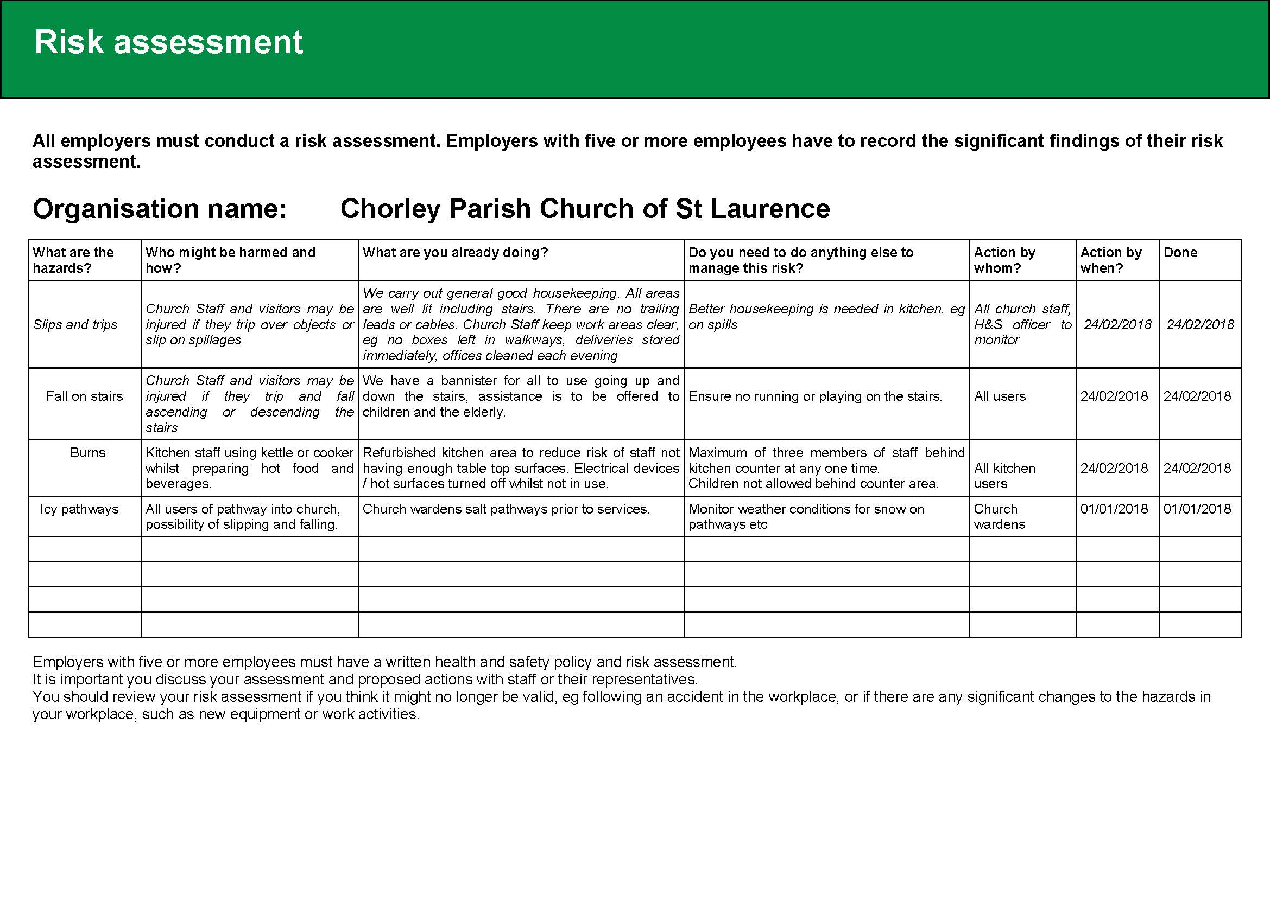

**Appendix 2 Fire Evacuation Plan**

|  |
| --- |
| **Fire Evacuation Plan** |

|  |  |
| --- | --- |
| **Emergency Evacuation Plan for :** | St Laurence’s Church |
| Premises address and contact number | Union St, Chorley PR7 1EB  01257 231360 |
| Plan date | 15/05/21 |
|  | |
| **Sound of the alarm** | |
| The sound of the alarm will be a continuous warning siren. | |
|  | |
| **Raising the alarm** | |
| In the event of a fire:  If the fire is discovered by a staff member or a visitor notifies a staff member of a fire, the alarm will be raised by: activation of the nearest call point or commencing manual warning (shout etc)  If fire is detected by automatic detectors, this will trigger the fire alarm | |
|  | |
| **Action staff should take on hearing the alarm** | |
| The following actions will be taken upon the fire alarm being sounded/raised:   * Church Wardens/ event leaders will take charge and lead in the fire evacuation * Dial 999 and request attendance by the Fire Service. Staff member gives their name, name of building, building address (as detailed above), contact number and details of fire * Staff/ event leaders will commence evacuation of the building, ensuring this is done in a calm and orderly manner, and direct people to the assembly point (corner of Union Street and Park Road, opposite side of the road to the church building) via the zebra crossing * Staff/ event leaders to sweep building to ensure all areas are clear (including back areas) if safe to do so and ensure all doors are closed on the way out * If safe to do, electrical mains and gas supplies should be switched off before leaving the building. * Church Wardens/ Duty Staff to ensure nobody re-enters the building until confirmed safe to do so by the Fire Service * Meet at assembly point (corner of Union Street and Park Road, opposite side of the road to the church building) by using zebra crossing and check all contractors/ visiting public and staff members are accounted for * Church Wardens/ Duty Staff to liaise with Fire Service upon their arrival | |
|  | |
|  | |
| **Escape routes** | |
| The escape routes from the building are:   1. Taste Café Kitchen Fire door 2. West wing door 3. Main entrance 4. Fire stairs from 1st floor room | |
|  | |
| **Fire assembly point** | |
| The assembly point is: Corner of Union Street and Park Road, opposite side to Church | |
|  | |
| **Fighting fires – Extinguisher use** | |
| Fire extinguishers will only be used where:   * Staff have received training and feel confident in their use * Where it is deemed safe to do so i.e. there is a clear means of escape, fire is small   **Personal safety always takes priority and, if in any doubt, staff should not attempt to extinguish a fire** | |
|  | |
| **Location of key safety hazards or other fire related equipment** | |
| * Gas supply shut off: Outside Plant Room (Rear of Church behind Refectory) * Mains fuse box: Refectory * Mains water inlet: Refectory * Location of fire alarm panel: Main entrance | |
|  | |
| **Number of staff needed to carry out evacuation plan** | |
| * To implement the evacuation plan, 2 members of trained staff are needed on duty * Between 08:00 and 12:00 on weekends/during special events, 2 staff need to be on duty at all times | |
|  | |
| **Equipment needed to effect the emergency plan** | |
| This includes:   * Office phone/ Mobile phone * evacuation chair (1st Floor) – unavailable at present. People with limited mobility are encouraged to use ground floor facilities only. | |
|  | |
| **Variations to plan** | |
| In the event of variations to normal working arrangements e.g. late opening, events, lone working etc:   * Duty staff /event leader to raise the alarm * Check building clear of personnel * Exit by quickest means | |

|  |
| --- |
| **Back up arrangements** |
| In the event of a power failure and automatic alarm failure:  Staff to raise the alarm by any means possible e.g shouting, whistle etc |

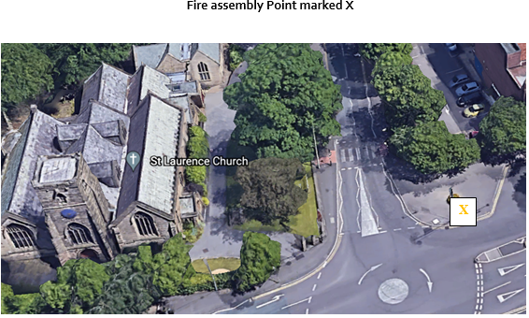

|  |  |
| --- | --- |
| **Responsibilities** | |
| For ensuring plan is up to date | Health & Safety Team |
| For ensuring adequate staff are on duty to carry out the evacuation plan | As above |
| For training staff on the evacuation plan and in their roles and responsibilities | As above |

|  |
| --- |
| Alternative arrangements will be made to cover staff absences/ leave etc to ensure there are always a sufficient number of trained staff available on site. |

1. *See* [*https://www.gov.uk/workplace-fire-safety-your-responsibilities*](https://www.gov.uk/workplace-fire-safety-your-responsibilities)

   *Assistance with a church fire risk assessment can be found at::* [*https://www.gov.uk/government/publications/fire-safety-risk-assessment-small-and-medium-places-of-assembly*](https://www.gov.uk/government/publications/fire-safety-risk-assessment-small-and-medium-places-of-assembly)